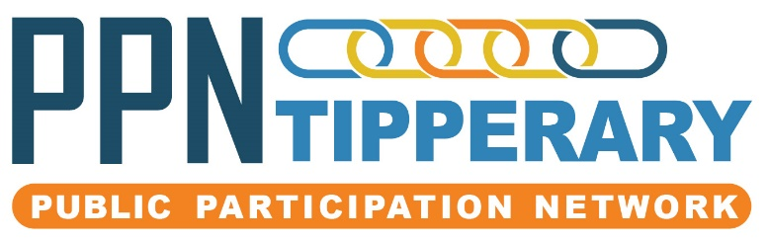

Minutes Secretariat 8th January 2020
Venue: TCEC @ 6.30pm
Facilitator: Anne Williamson
Minute taker: Mike Edwards
Secretariat members present:
Michael Kealy, Ruth Smith, Anne Williamson, Charles Stanley Smith, JJ O’Sullivan, Evelyn Norton, Sean O’Farrell and Mike Edwards.
In attendance: Avril Wilson
Apologies: Derry O’Donnell, Mary Ryan and Helen Butler.
- Apologies
- Conflict of interest
- Agenda and A.O.B.
- Minutes, due to unforeseen events Minutes were not available, however this is being rectified and the minutes will be proposed at the next meeting.
- Finance update, as per Co-ordinators report provided
- Following discussion at Novembers secretariat meeting where the FSC and Staff Liaison sub committee recommended a pay increase to commence from January the 1st 2020 for both staff,
- the Secretariat agreed and will instruct the company to implement change to salaries and contracts.
- Directors update:
  - Governance code was discussed and is to be forwarded
  - Ciaran Lynch was unable to attend,
  - Wage increase proposed and agreed by Secretariat to commence to start from 01st January as agreed
  - Registration with Lobbying.ie, a National view is to be sought to clarify the position of same.
- LCDC Contract is signed for Website design.
- Website subgroup: Charles and Michael – Avril to arrange a date re meeting website developer.
- The Secretariat National Network: Charles gave feedback and the next meeting is 11th February.
- Terms of reference: It was felt that the Guidebook should come before the Constitution, new policies could be developed once handbook was agreed and complete after the National review of the PPN,
- User guide review: Discussion on inconsistencies and the length of the handbook were raised, some felt it was too repetitive while other mentioned that sectionally it might be good for groups to use for their own specific areas.

- Reps and secretariat vacancies, it was noted that the call for same had gone out again and that if needed the call could be repeated at the Next Wellbeing Statement Workshop (Nenagh MD)
- The next wellbeing Statement workshop is set for Toomevara GAA hall 21st January 2020, facilitators are, Mike, Ruth, Sara TVC, Joanne Mc, Anne and Evelyn. Everyone was reminded to encourage attendance.
- Workplan subcommittee have agreed a quarterly review by secretariat with emphasis on the 4 goals.
- Training as per Coordinators report Hands for Life CPR training via Irish Heart Foundation in Littleton
- Mindfulness for the Autumn
- Committee skills for the Autumn
- Avril raised the issue of SPC training for reps and will again bring to the attention of the County Council admin team
- Clonmel Wellbeing, possible venues; Clonmel Enterprise Centre, The Museum, facilitators are, Charles, Evelyn, Ruth, Mike, Tina and Hillary.

14. Date of next meeting is 19th February – Avril will send around a list of dates for meetings for the coming year.

15. Correspondence from EirGrid, a meeting to allow Secretariat, SPC reps and any groups interested to hear from EirGrid, and their plans was agreed.

